**S/4 HANA MM Exercise:**

**By: Pankaj Kumar**

Step 1: Create New Supplier

Submit a screen shot of Partner Functions tab screen (2.5 points)

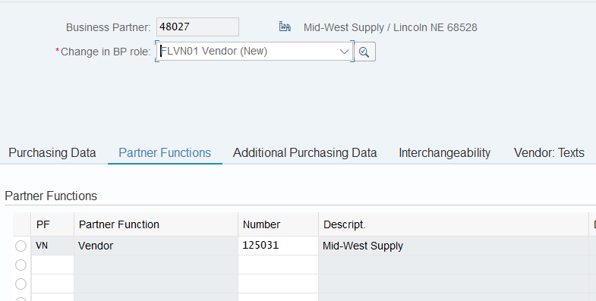

Step 2: Create Material Master for Trading Goods

Submit the screen shot of the conditions screen (2.5 points)

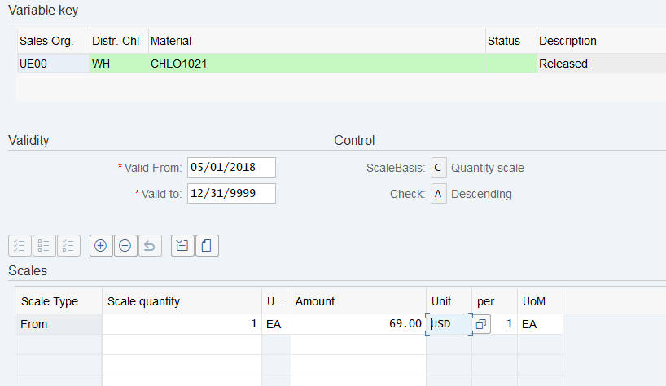

Step 3: Extend Material Master for Trading Goods

Submit the screen shot of Sales Org1 tab screen (2.5 points)

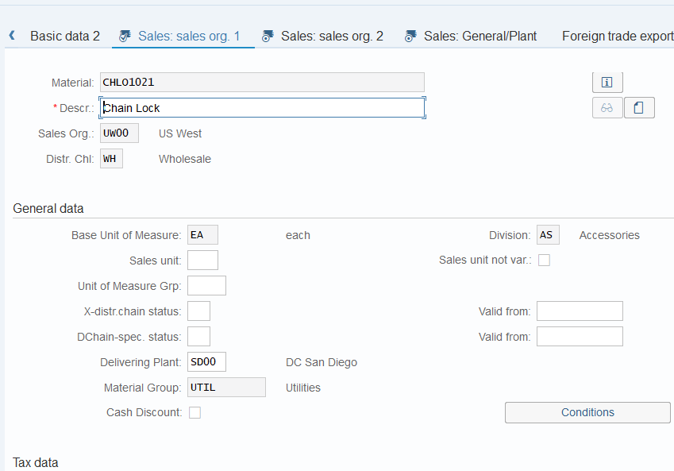

Step 4: Display Stock/Requirements List

Submit a screenshot of Stock/Requirements List (2.5 points)

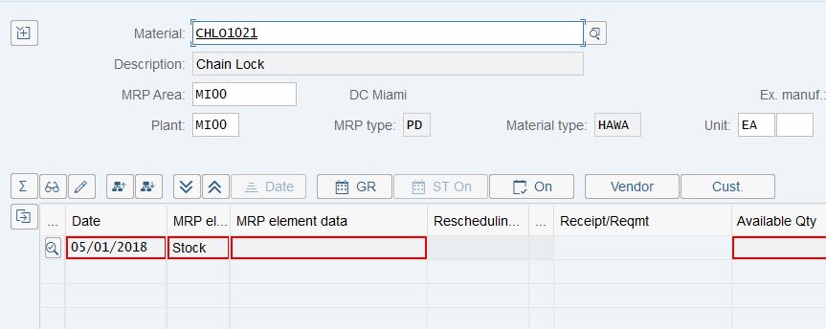

Step 5: Create Purchase Requisition

Submit a screen shot of purchase requisition screen (2.5 points)

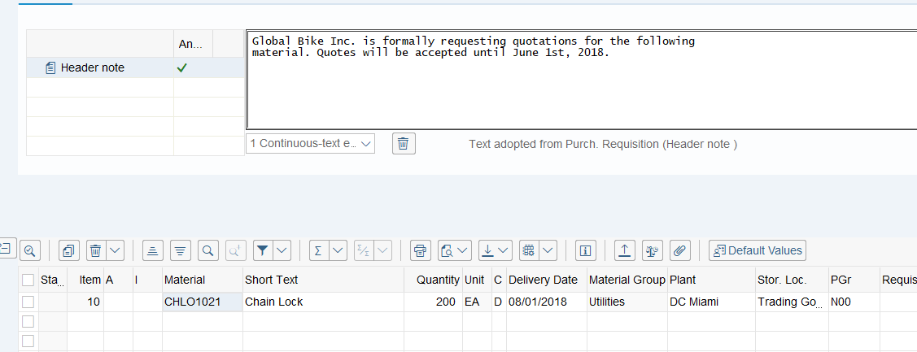

Write down your purchase requisition number

**:- 0010000035**



Step 6: Display Stock/Requirements List

Submit the screen shot of Stock/Requirements List (2.5 points)

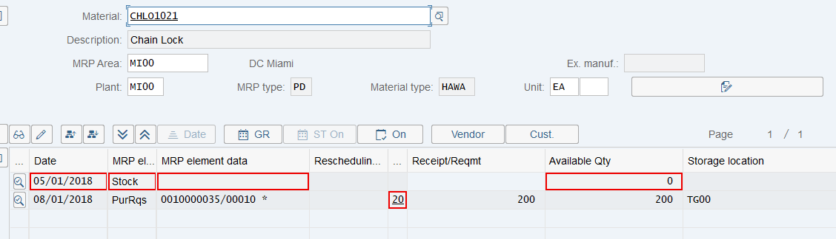

Step 7: Create Request for Quotation

Submit a screen shot of the Selection of Purchase Requisition screen (2.5 point)

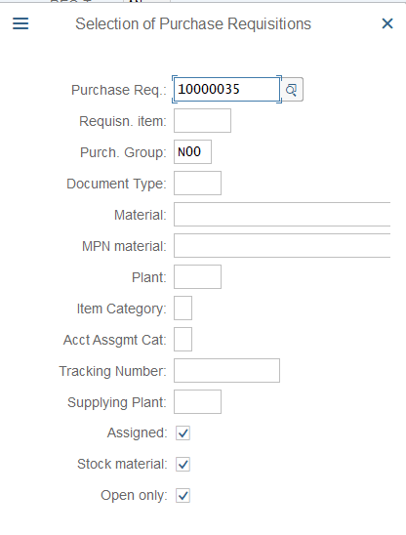

Submit the screen shot of Create RFQ Supplier Address Screen for Mid-West Supply(2.5 points)

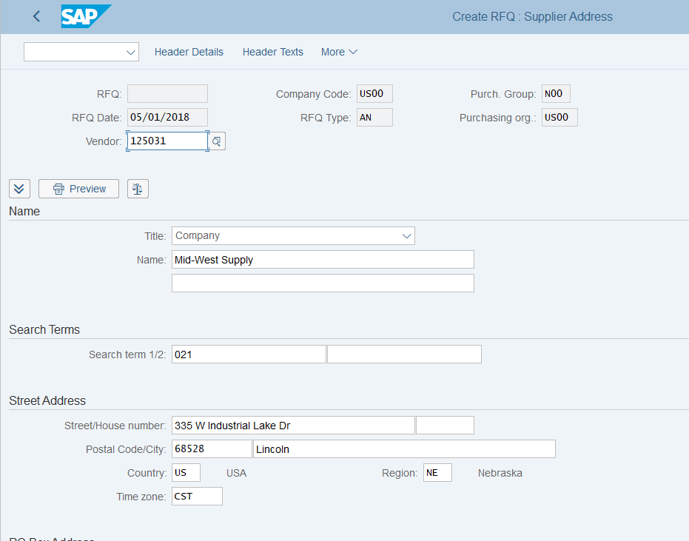

Write down your RFQ numbers.

:-

Mid west:- 6000000085

Dallas: ….86

Spy Gear: …..87

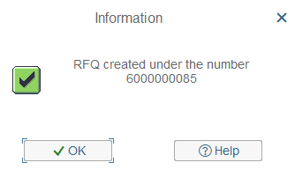

Step 8: Maintain Quotations from Vendors

Submit screen shot of Maintain Quotation: Item Overview for Spy Gear (2.5 points).

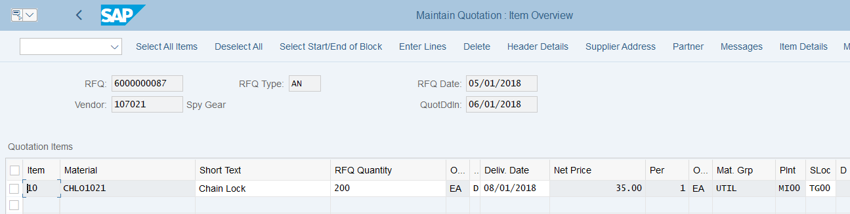

Step 9: Evaluate quotations on price

Submit the screen shot of Price Comparison List in Currency USD (2.5 points).

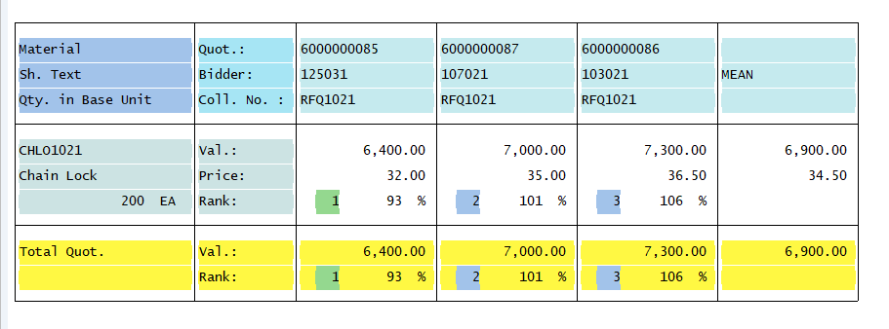

Step 10: Create Purchase Order Referencing an RFQ

Write down purchase order number.

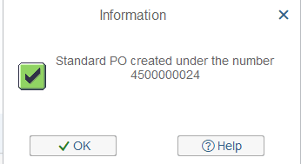

**4500000024**

Step 11: Display Purchase Order

Submit the screen shot of the Delivery Schedule tab screen (2.5 points)

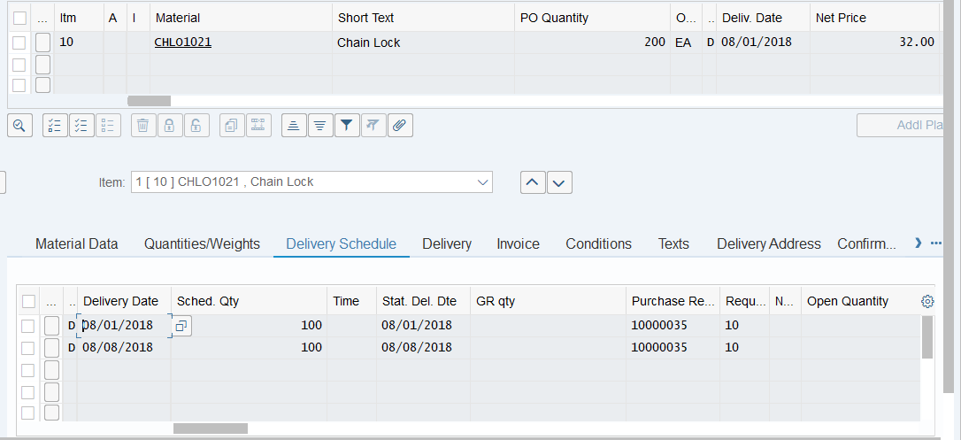

Step 12: Create Goods Receipt for Purchase Order

Write down the material document number.

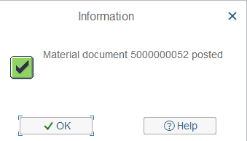

Step 13: Verify Physical Receipt of Goods

Submit the screen shot of Stock Overview Basic List Screen (2.5 points)

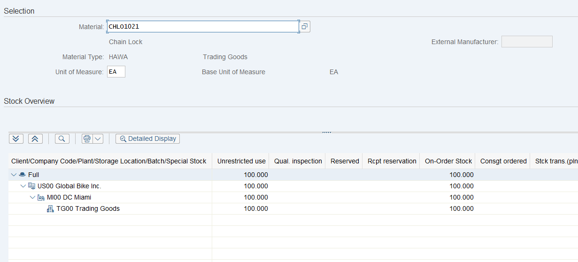

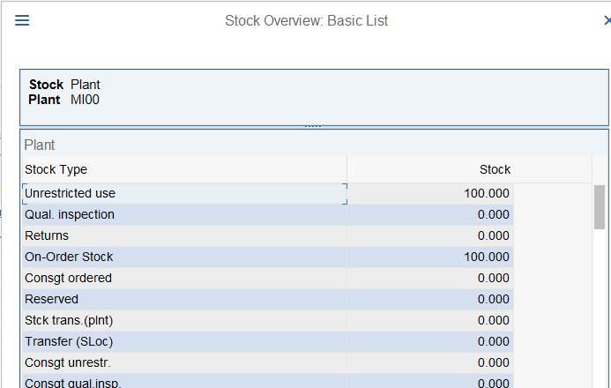

Step 14: Create Invoice Receipt from Vendor

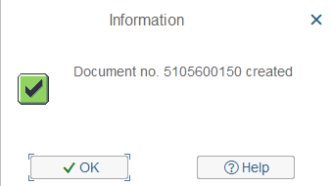

Step 15: Display Purchase Order History

Submit a screen shot of the Purchase Order History tab screen (2.5 points).

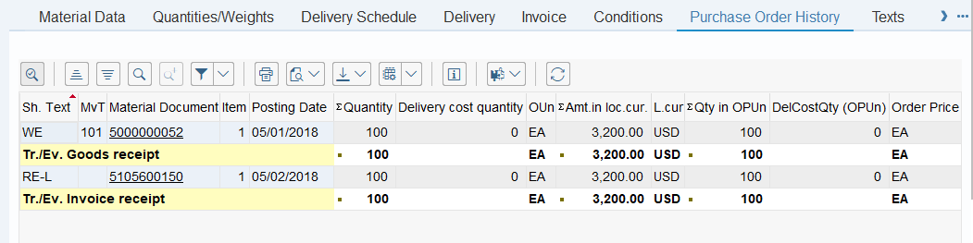

Submit a screen shot of the Display Document Data Entry View (2.5 points)

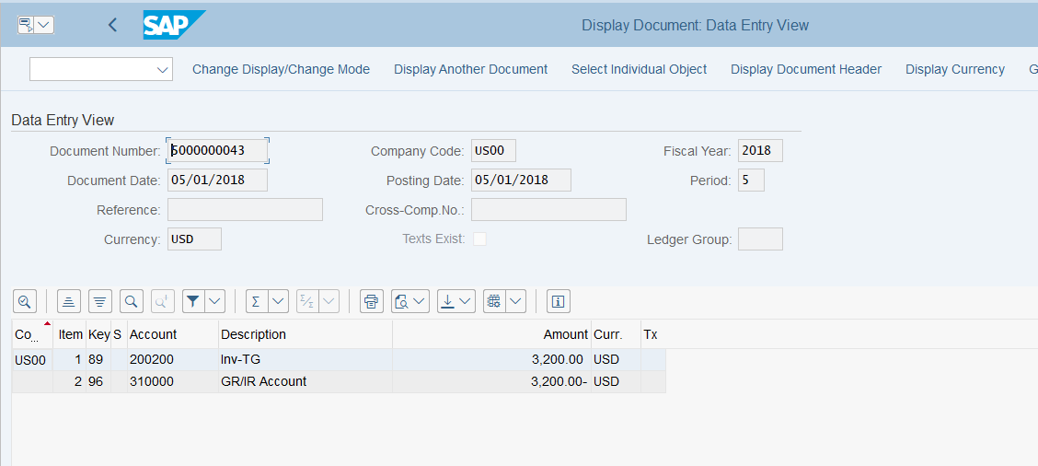

Step 16: Create Goods Receipt for Purchase Order

Step 17: Create Invoice Receipt from Vendor

Step 18: Post Payments to Vendor

Submit the screen shot of Post Outgoing Payments: Header Data (2.5 points)

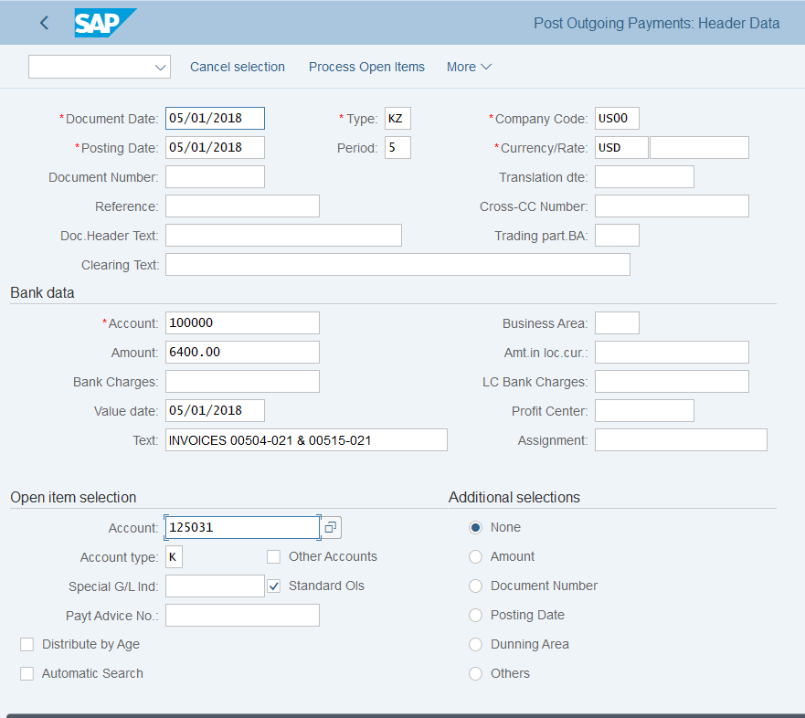

Submit the screen shot of the screen showing a balance of 0.00 for Not assigned (2.5 points)

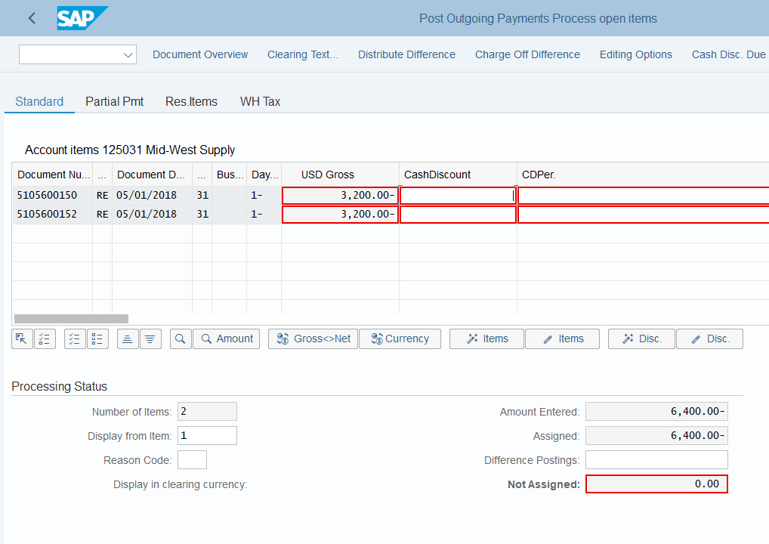

Step 19: Display Vendor Line Items

Submit a screen shot of the Bal tab screen (2.5 points)

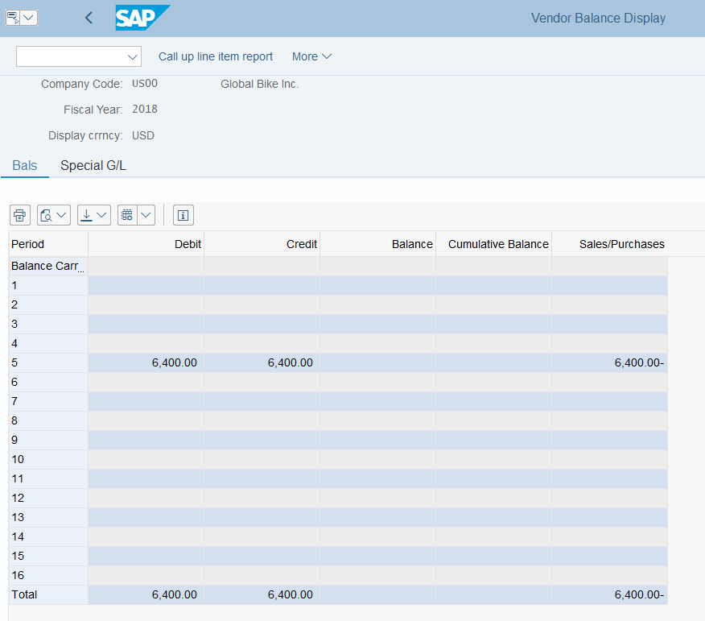

Step 20: Display Purchase Order History

Submit a screen shot of the General Ledger posting (2.5 points

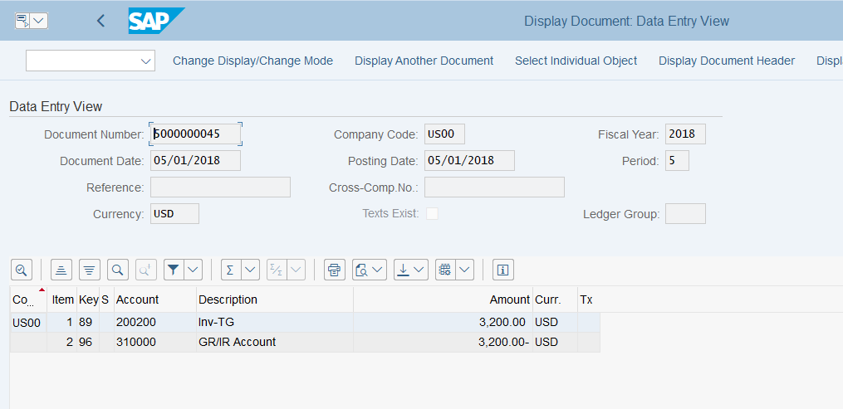

Step 21: Display/Review G/L Account Balances and Individual Line Items

Submit the screen shot of G/L account balances for 2017 (2.5 points).

